Electronics Exam Solutions

Question 5(a): 555 Timer as One-Shot/Monostable Multivibrator

i) Explain the operation of the circuit:
The 555 timer configured as a monostable multivibrator (one-shot circuit) operates as follows:
- When the trigger input (pin 2) receives a pulse that drops below 1/3 of the supply voltage, the circuit is triggered and produces a single output pulse of predetermined duration. The output (pin 3) goes HIGH and remains HIGH for a duration determined by the RC time constant (R and C external components). During this period, the discharge pin (pin 7) is open (HIGH), allowing the capacitor C to charge through resistor R. When the capacitor voltage reaches 2/3 of the supply voltage, the threshold comparator (pin 6) triggers the reset of the flip-flop, the output goes LOW, and the discharge pin becomes active, rapidly discharging the capacitor through the internal discharge transistor. The circuit then returns to its stable state, waiting for the next trigger pulse.

ii) Draw the output waveforms with the trigger input:
The output waveforms would show:
- Trigger Input: A series of short pulses (negative-going)
- Output Pulse: For each trigger pulse, a fixed-width rectangular pulse of duration T = 1.1 × R × C seconds
- The output pulse width is independent of the trigger pulse width, as long as the trigger pulse is shorter than the output pulse. 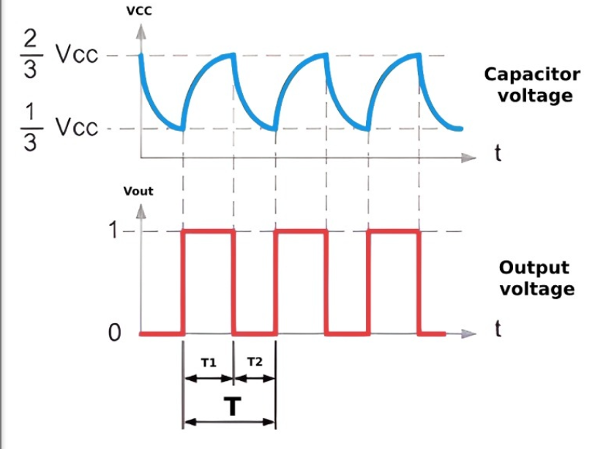
[In an exam, you would draw: trigger pulses spaced apart, and rectangular output pulses of fixed duration starting after each trigger pulse]

iii) Determine the period of output waveform for the circuit when triggered by a negative pulse:
The period (duration) of the output waveform is determined by the external timing components R and C:

T = 1.1 × R × C
Where:
- T = output pulse duration (in seconds)
- R = external resistor (in ohms)
- C = external capacitor (in farads)
- 1.1 = constant for the 555 timer in monostable mode

iv) Convert this circuit to that it operates in an astable mode:
To convert the monostable circuit to astable (free-running oscillator) mode, the following modifications are needed:
- Connect the discharge pin (pin 7) through a resistor (R2) to the capacitor instead of directly to ground. The circuit now has two resistors (R1 and R2) and the capacitor. The output continuously oscillates between HIGH and LOW states without requiring external trigger pulses.
- In astable mode: The capacitor charges through R1 and R2 (when output is HIGH), and discharges through R2 only (when output is LOW).
Frequency: f = 1.44 / [(R1 + 2R2) × C]
Duty Cycle: D = (R1 + R2) / (R1 + 2R2) × 100%

Question 5(b): 100-W Heater Control using SCR

i) Why are mercury-in-glass thermostats not suitable?
Mercury-in-glass thermostats have several limitations for precise temperature control:
- Limited sensitivity: Mercury thermostats have relatively poor temperature resolution and cannot detect small temperature changes. They are most accurate at specific calibration points.
- Mechanical hysteresis: They exhibit hysteresis, meaning the on/off switching points differ depending on whether temperature is rising or falling. This results in temperature oscillations.
- Slow response: The thermal mass of the glass bulb causes slow response to temperature changes, leading to overshoot and undershoot.
- Incompatibility with electronics: Mercury contacts are not directly compatible with electronic circuits; they require relay interfaces.
- Toxicity hazard: Mercury is toxic and poses environmental and health risks if the thermometer breaks.

ii) Explain the operation of the circuit:
The SCR (Silicon Controlled Rectifier) acts as an electronic switch controlled by the thermistor-based temperature sensing circuit:
- The thermistor changes resistance with temperature. As temperature increases, its resistance decreases (assuming an NTC thermistor). This changes the voltage at the gate of the SCR through a voltage divider network.
- When the gate voltage exceeds the gate threshold voltage (approximately 0.6-0.7V), the SCR turns ON, allowing current to flow through the 100W heater load from anode to cathode.
- When temperature exceeds the setpoint, the thermistor resistance decreases such that the gate voltage falls below the threshold. The SCR turns OFF at the next zero-crossing of the AC supply, disconnecting the heater.
- This creates a hysteresis-controlled ON/OFF switching that maintains the temperature within a narrow band around the setpoint.

iii) Sketch the waveform across the SCR for full-wave rectified waveforms:
The waveform across the SCR (anode-to-cathode voltage) depends on whether the SCR is conducting or not:
- When SCR is OFF (not conducting): The full sinusoidal waveform appears across the SCR with peak voltage V_peak ≈ √2 × V_rms (for 120V AC input, ≈ 170V)
- When SCR is ON (conducting): The voltage across the SCR drops to approximately 1-2V (the forward voltage drop of the SCR in conducting state)
- By controlling the gate signal via the thermistor, different phase angles can be achieved, producing waveforms that vary from nearly zero current (SCR barely on) to full current (SCR fully conducting).

iv) Once the thermostat reaches its temperature and assumes the short-circuit state, how will the SCR react?
When the thermostat reaches the set temperature and transitions to a short-circuit state:
- If the thermostat (or its equivalent circuit) goes to short-circuit, the gate voltage will drop significantly, typically to 0V or below. This removes the gate triggering signal from the SCR.
- The SCR will turn OFF at the next zero-crossing of the AC supply (at the end of the current half-cycle). SCRs can only be turned off by reducing the anode current below the holding current, which naturally occurs at the AC zero-crossing.
- Result: The heater disconnects, and no current flows through it. The temperature will begin to drop, and when it falls below the setpoint, the thermostat will again supply gate current, reactivating the heater.

v) Is it possible to use a TRIAC instead of SCR? What is your comment?
Yes, a TRIAC can be used instead of an SCR, and in many ways it is superior for AC applications:
- A TRIAC is a bidirectional thyristor that can conduct in both directions (positive and negative half-cycles of the AC waveform). It functions as two back-to-back SCRs.
- Advantages of TRIAC over SCR for this application:
- Full-wave power control: The SCR only uses half of the AC cycle (one polarity), wasting half the power. A TRIAC uses both half-cycles, allowing full-wave control and better efficiency.
- Smoother control: TRIAC provides more gradual power adjustment by controlling both positive and negative half-cycles, reducing audible noise from the heater.
- Simpler circuit: No additional diodes or rectification is needed; the TRIAC directly switches the AC signal.
Comment: Using a TRIAC in this circuit would improve efficiency, reduce power losses (due to full-wave operation), and provide better temperature control stability. For a 100W heater load, the cost difference between an SCR and TRIAC is minimal, making the TRIAC the preferred choice for practical applications.

Question 5(c): FET Phase-Shift Oscillator

i) Design the capacitor C for the specified oscillator operation:
Given:
- g_m = 6000 μS (transconductance)
- f = 50 kHz (operating frequency)
- Need to design for sustained oscillation

For a phase-shift oscillator, the frequency of oscillation is given by:
f = 1 / (2π√6 × R × C)
(for a 3-stage RC phase-shift network)

Rearranging for C:
C = 1 / (2π × f × √6 × R)

Substituting values:
- C = 1 / (2π × 50×10³ × √6 × R)
- C = 1 / (2π × 50×10³ × 2.449 × R)
- C = 1 / (770,000 × R) farads
- C ≈ 1.3 / R µF (if R is in kilohms)

For gain stability (oscillation condition):g_m × R_d × R₂ × R₃ ≥ 23

This ensures sufficient gain in the feedback loop for oscillation to be sustained.

ii) Derive the amplifier gain magnitude and find R for a 29 Ω ensure oscillation:
The amplifier gain magnitude is calculated from the feedback network:

|A_v| = g_m × R_d
(open-loop voltage gain of FET amplifier)

For a phase-shift oscillator with 3 RC stages, the loop gain condition is:
g_m × R_d × R₂ ≥ 23
(for oscillation with unity feedback)

Given g_m = 6000 μS = 0.006 S:
0.006 × R_d × R₂ = 29

R_d × R₂ = 29 / 0.006 = 4,833 Ω ≈ 4.8 kΩ

If we assume equal resistor values in the phase-shift network (R₁ = R₂ = R₃ = R), then:

R_d × R ≥ 4,833

For practical design with R_d and R being comparable:
- If R_d = 10 kΩ, then R ≈ 480 Ω
- If R_d = 5 kΩ, then R ≈ 970 Ω
- Or use a variable resistor for tuning around the designed values

iii) Crystal oscillation using series-resonant frequency:
A quartz crystal connected in the series-resonant configuration:
- The crystal acts as a very high-Q resonant circuit with two closely spaced frequencies: series resonance (f_s) and parallel resonance (f_p). At f_s, the crystal impedance is minimum (purely resistive); at f_p, impedance is maximum.
- When the crystal is connected in series with the drain circuit, it provides extremely selective feedback. The oscillator will oscillate only at the series-resonant frequency of the crystal.
- Advantages of crystal oscillators:
- Extremely high frequency stability (parts per million accuracy)
- Low drift over temperature and time
- Excellent frequency selectivity due to high Q factor
- Reduced power consumption compared to RC oscillators

The series-resonant frequency is given by:
f_s = 1 / (2π√L_m × C_m)
where L_m and C_m are the motional inductance and capacitance of the crystal.

Crystal oscillators are preferred in precision applications, frequency standards, and communication systems where frequency stability and accuracy are critical requirements.

Summary of Key Formulas
Circuit/Component | Key Formula
555 Timer - Monostable | T = 1.1 × R × C
555 Timer - Astable Frequency | f = 1.44 / [(R1 + 2R2) × C]
555 Timer - Astable Duty Cycle | D = (R1 + R2) / (R1 + 2R2) × 100%
Phase-Shift Oscillator Frequency | f = 1 / (2π√6 × R × C)
FET Amplifier Gain | |A_v| = g_m × R_d
Oscillation Loop Gain Condition | g_m × R_d × R ≥ 23 (for 3-stage network)
Crystal Oscillator Frequency | f_s = 1 / (2π√L_m × C_m)

